**COE318 – Lab 2: Linked Counters**

**Objectives**

* Implement a Counter class.
* Learn how objects can be linked together.
* Use an “if” statement.

**Duration:** one week.

**Grading Scheme:**

50% submitted source code

25% in-class demonstration and questions (during week 3 lab hours)

25% in-class quiz – Held during the first 5 mins of the lab class (during week 5 lab hours)

**Overview**

In mathematics, a number is expressed in positional notation to a certain base, B

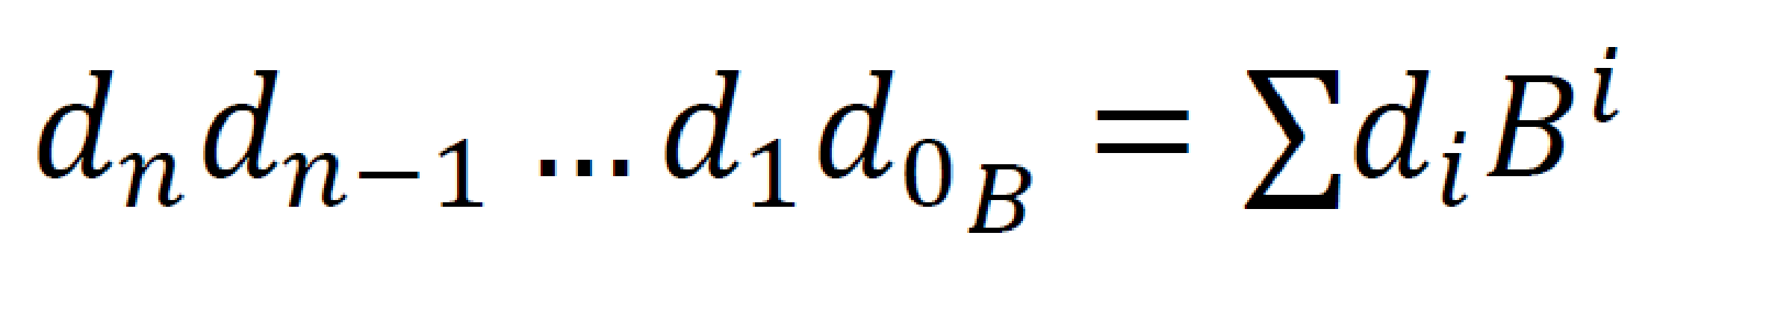

For example, the 3-digit number 123 in base 4 represents 16+8+3=27 (base 10).

In this lab each digit is represented as a Counter object. A Counter object has an optional left neighbour which is also a Counter object. (The absence of a left neighbour is indicated with the keyword null.

The important methods to implement are getCount() and increment(). If there is no left neighbour, the count is the same as the digit.

If there is a left neighbour, the count is the sum of the digit and the modulus times the count of the left neighbour.

The increment() method increments the Counter's digit and, if it reaches its maximum (modulus) value, it is reset to zero. Furthermore, if there is a left neighbour and if the Counter has rolled over, its left neighbour should be incremented as well.

**Source Code**

Similar to the previous labs, Counter.java and CounterTry.java are provided with the handout.

**Step 1: Create a Netbeans Project**

1. Create a Netbeans project called Counter which should be placed in a folder called lab2 (all lowercase and no spaces). The lab2 folder should itself be in your coe318 folder.
2. Create a Java file (class library type) called Counter; set the package to coe318.lab2; then copy and paste the provided source code.
3. Similarly, create the Java file CounterTry. (Ensure you use the same coe318.lab2 package name.
4. Generate the javadocs and compile and run the project.
5. It should compile correctly and produce output. Unfortunately, the output is incorrect and you have to fix it.

**Step 2: Add instance variables and fix constructor and getters**

1. Add instance variables for the two components of a counter.
2. Modify the constructor so that they are properly initialized.
3. Fix the remaining methods so that they work for a simple counter without a left neighbour.

**Step 3: Fix remaining methods**

1. Fix the remaining methods.

**Step 4: Submit your lab**

You must submit your lab electronically on D2L. Please make sure you hand over the quiz answer sheet to the TA at the end of the in-class quiz.

Please zip up your NetBeans project containing all source files and submit to the respective assignment folder on D2L.